Safety statement!

When using, be sure to pay attention to safety! Avoid being injured by the machine!

Tip: If there is an emergency, please click the emergency stop button on the software immediately, or cut off the 12V power supply!

Quick start:

1. Please insert them into the right motor socket of the control according to the stickers on the motor cable.
2. After all the required actions are edited, please press the "Start" button to check whether the actions are all normal and confirm that there is no Incorrect, insert the infrared sensor to the control, please refer to the figure below.
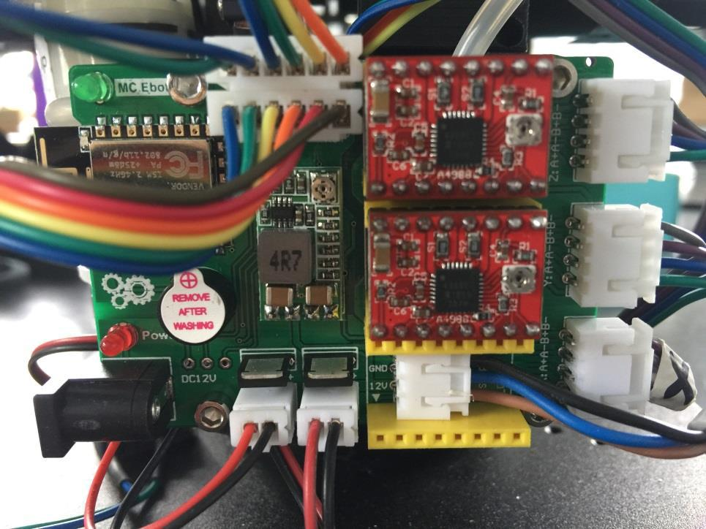

Specially designed for production line handling and can be run offline

Features: Mobile APP (currently only Android) on-site programming, using teaching mode, point programming mode.
Users do not need to have any knowledge of G code, nor do they need to touch any machine coordinates, etc.~
Note: Each axis of the machine must have a limit switch! ! ! (One for each axis is fine)

Board peripheral introduction:

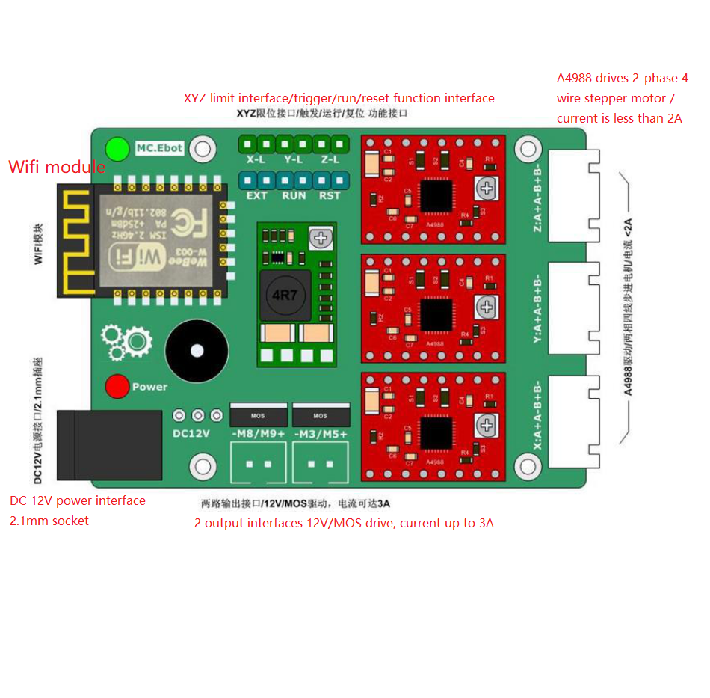The main shaft interface supports PWM setting, and the duty ratio can be set by sending S command through APP. The fan interface does not support PWM.

Ready to work:

Confirm the motor wire sequence, the control board interface sequence is AABB, and connect the three motor wires.

(A4988 drive, only supports motors with current less than 2A and rated voltage between 8-32V!)

(If the motor is not marked with rated voltage, then measure the phase resistance to ensure that the phase resistance is greater than 5 ohms!)

.

Wiring instructions:

Connect the limit switch line, X-L connects to the machine chassis, Y-L connects to the machine's auxiliary arm (forearm), and Z-L connects to the machine's main arm (boom).

RST, RUN, EXT are respectively connected to a tact switch, the functions are in order: reset/emergency stop (red button), power-on calibration (yellow button), external trigger (green button).

APP interface:
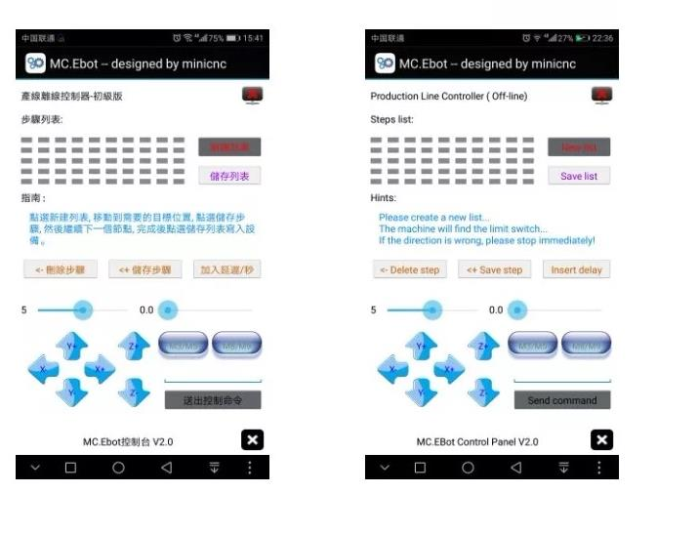
First use:

After the control board is powered on, a WIFI signal will be generated, the name is MC _Ebot_xxx and the password is MiniCNC_xxx. After the phone is connected, open the APP, as shown in the figure above.

1: Confirm the direction of the manual move button:

PS: Two sliders for button step adjustment, you can set the size of each step.

PS: The movement direction below is just a general habitual setting, according to personal preferences, there is no mandatory requirement...

Click X+/-, the machine will rotate counterclockwise, if it is reversed, send "C X" to adjust it. (Do not use quotation marks) After setting, press Reset/Emergency Stop to take effect.

Click Y+/-, the machine's auxiliary arm (forearm) will rise/fall, if it is reversed, send "C Y" to adjust it. (Do not use quotation marks) After setting, press Reset/Emergency Stop to take effect. Click Z+/-, the main arm (boom) of the machine will rise/fall, if it is reversed, send "C Z" to adjust it. (Do not use quotation marks) After setting, press Reset/Emergency Stop to take effect.

2: Confirm automatic calibration direction:

Click the new list on the software, and the machine will automatically search for the limit switch. If the search direction of an axis is not in the direction of the limit switch, please press the reset/emergency stop button immediately! If the direction of the chassis is reversed, send "HX" to adjust it. (Do not use quotation marks) After setting, press Reset/Emergency Stop to take effect.

If the direction of the auxiliary arm is reversed, send "HY" to adjust it. (Do not use quotation marks) After setting, press Reset/Emergency Stop to take effect. If the direction of the main arm is reversed, send "HZ" to adjust it. (Do not use quotation marks) After setting, press Reset/Emergency Stop to take effect.

After all settings are set, click New List, and the machine will automatically search for limit switches until all three limit switches are triggered, and then stop. Wait for the programming action.

3: Programming action:

1> Use the manual move button to move the machine to the stop point first. (Stop point refers to the position where you want the machine to stop when the machine is idle.) Click to save the step.

Note: During the movement, the limit switch cannot be triggered. If it is accidentally triggered, please click New List to start again. 2>Use the manual move button to move the machine to the working path, the first key point to be reached. Click to save the step. At this point, do I need to turn on the spindle or fan? If yes, please click M5 or M8 to turn on the spindle or fan, and the button will change to M3 or M9. Click to save the step. Do I need to pause for a while after turning on the spindle or fan? (Sometimes such as waiting for the suction cup to stabilize before moving

If you need to wait for 1 second, adjust the step adjustment slider, for example, adjust it to 1. Click to insert a delay.

...The second key point to be reached. (Same as above)

...

...The Nth key point to be reached. (Same as above) (maximum record 50 steps)

- After editing the action, click Save List and save the entire step to the control panel. It takes about one minute. After saving, the board will continue to be di di di di di di di di...

4>You can turn off the APP. At this time, press the reset/emergency stop button, and then press the power-on calibration button, and then the machine will first search for the limit switch automatically, and then move to the stop point when found.

5>Click the external trigger button, the machine will execute the set action once, and then return to the stop point. Wait for the next trigger.

Normal use:

1: Power on

2: Press to reset/emergency stop

3: Press to power on and calibrate (the machine automatically finds the limit switch and then moves to the stop point)

4: When triggered externally, the programmed action will be executed, and then return to the stop point again, waiting for the next trigger.

.

Speed, spindle power:

Because this control board does not need to know the parameters of the machine, so there are not many parameters that need to be set.

as follows:

1. Machine running speed setting: send control command F, such as F500, the maximum is 5000.

2. The acceleration and XYZ axis commands are 120, 121, 122 respectively. First send the control command 120=50, the green light stops flashing, wait for the green light to recover, and then set the Y axis and Z axis in the same way, 121=50, 122=50 ,

- The limit switch resets the return distance parameter, and sends the control command 27, such as sending the command 27=5, after sending, the green light stops flashing, wait for the buzzer to prompt, the green light resumes flashing, the setting is completed, please change the number according to the actual situation" 5"
4. Spindle interface PWM setting: send control command S, such as S5000, the maximum is 10000 (100%).

